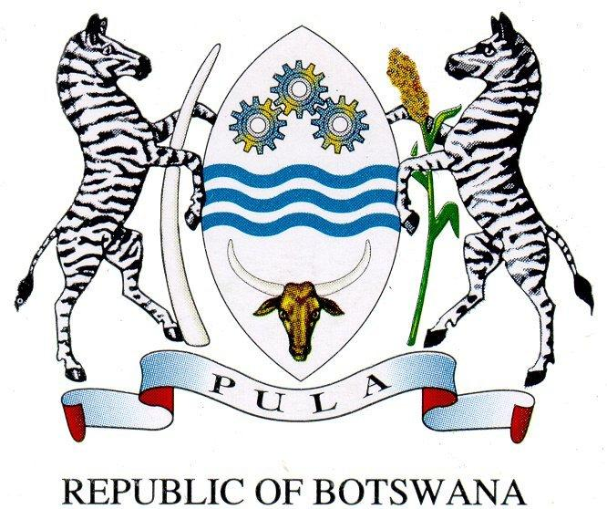

Keynote Address by
Major General Bakwena Oitsile (Rtd),
Chairman of BOCRA Board of Directors
during the occasion of the World Radio Day

13 February 2019
Hukuntsi

PROTOCOL OBSERVED
Good Morning!
Allow me to begin, without prejudice, by making the observation that, very few media facilitate participatory democracy better than Radio. While the objectives of informing, educating and entertaining are mainly associated with Public Service Broadcasting, radio broadcasting, in all its various forms, is perhaps the only medium that is most accessible and convenient for public discourse. Owing to its ease of availability through affordable radio sets, mobile handsets and car radios, Internet radio etc, radio is arguably the only medium through which we can achieve the concept of ubiquitous access. It is therefore, fitting that annually we pause and evaluate the contribution that radio continues to make to our lives.

It is a great honour for me that I am able to join you on this very special day for our sector and the country as a whole. Today it’s all about radio and I am positive that there is no one in this country who has not interacted with radio in one way or the other. It therefore makes my job easy that I will be talking about subject that we are all familiar with.

It is common course that technology evolves daily. Technology that was applicable 30 years ago is certainly different from the one that is available today. Obvious examples include, a computer, a cell phone, a television or even simple cooker. The initial computer was a big box used only in offices with limited capability. The only phone we knew in the 70’s and early 80’s was a fixed line telephone which could only do voice calls. We were later introduced to a brick size cell phone which could only do voice calls and Short Messaging Services (SMS). Anyone here who may still be keeping the older version of the gadgets I have just referred to will realise that most of them do not work in the current environment or if they do, they will prove wanting for our modern-day requirements.

Throughout its various stages of evolution, technology has changed our way of life for the better. These days we demand technology that offers convenience, speed, efficiency and gives us control. Advancements in computer technology have given us Internet and Internet of things, artificial intelligence, intelligent cars with accident mitigation and self-parking or self-driving capabilities, blockchains, smart cities etc. These applications and services have certainly improved our quality of life, in terms of safety, healthcare, environment and many other aspects.

However, one technology that has stood the test of time is radio. Often, we have to change our mobile phone handsets because after a period of about four (4) years these devices become literally irrelevant! By comparison, I can guarantee you that if you were to get your 30-year-old radio set and switch it on right now, it will still tune in and receive the available services. That is a good example of why this medium has maintained its relevance!
Radio broadcasting has made it possible to reach the widest audience including low income communities, vulnerable groups, women and children, the uneducated and very remote communities at comparatively very low cost. Hence, radio has been and remains key to our nation building, promoting diversity, tolerance and acceptance.

I know that a lot of our young generation subscribe to social media, but in my observation, modern media like social media, has a tendency of attracting only people with similar beliefs and values. On the contrary, radio has been pivotal in bringing together people of different believes and ideologies. Radio remains dynamic and has indeed adapted to the modern demands making it easier for people from all walks of life to interact and participate.

It is recognition of this unique quality of radio that, as a country, we join the international community today in celebrating World Radio Day 2019. The commemoration aims to improve international cooperation among radio broadcasters as well as to create and provide access to information through radio.

The theme for this year’s commemoration says “Dialogue, Tolerance and Peace”. The theme is intended to promote radio broadcasts that provide a platform for dialogue and democratic debate over issues such as, violence against women and children. It is also targeted at raising awareness and inspiring broadcasters to meet the diverse needs of individuals through positive action. Hence, the organisers found it fitting to coin the messages; #WorldRadioDay19; #A Re Bueng; #A he bole with a view to encouraging the nation to openly discuss the issues I have highlighted earlier that are bedevilling our nation.

It is also opportune that the commemoration fits well into the nationwide campaign against violating children rights, #Eseng Mo Ngwaneng. The recent statistics reveal that abusing children is a cancer that is robbing our children of the bright future that God has intended for them. We are duty bound to take part and send clear messages against this social ill under the auspices of World Radio Day. Later on, we will listen to important discussions from the people who deal with this scourge on the ground, the police, the social workers and others. As I said earlier, we should be inspired to make a positive change.

Government has made significant investment towards expanding broadcasting network, which today boasts of a coverage of 90% for radio and 80% for television. Last year, Cabinet made a decision that, among other things, all the government broadcast transmission Infrastructure must be shared with commercial broadcasters. The object of this decision is to ensure that there is no duplication of investment in broadcast transmission infrastructure. As government, we believe that relieving commercial broadcasters of the burden of investing in transmission infrastructure, will allow them to roll out services relatively quicker and ensure that citizens of this country have access to services regardless of geographic position on the map.

In 2014 BOCRA established the Universal Access and Service Fund (UASF) to facilitate roll out of communications service throughout Botswana. The Fund aims to promote uniform level of services to all users of communication services with respect to price and quality of services, particularly, to unserved and underserved areas that are otherwise considered unprofitable.

The Fund has already made notable progress. You may be aware that all primary schools in the whole of Kgalagadi District, Ganzi District and Mabutsane Sub-District are now connected to the Internet and have also received educational tablets. It was through the UASF that the schools’ computerisation project was made possible. The Fund has also facilitated the upgrade of mobile base stations to 3G or better and employed 68 IT Officers. Last week we were in Mabutsane launching that project. We will return to launch the same project in Kgalagadi District.

In commemorating the Radio Day today, the Fund in collaboration with strategic partners including Botswana Fibre Networks (BoFINET), Department of Broadcasting Services, Commercial Broadcasters and our equipment supplier Plastique (Pty) Ltd, have made contributions to sponsor the roll out of new transmitters for commercial radio stations in Hukuntsi and Sojwe. This contribution demonstrates commitment to Infrastructure Sharing as a model for reducing costs of service provision and facilitating service delivery to all.

Finally, Director of Ceremonies; Ladies and gentlemen, it gives me great pleasure to declare the World Radio Day 2019 commemoration officially launched. In doing so, I am greatly honoured to announce that commercial radio stations are now available in 4Huks on the following frequencies;
DUMA 99.4 MHz
GABZ FM 102.9 MHz
YARONA FM - 92.9 MHz
Coverage of these radio stations is not limited to Hukuntsi only but extends to villages within 50 Kms of Hukuntsi including Lehututu, Lokgwabe and Tshane. This means that the people of these villages and nearby masimo and meraka will from today enjoy diversity of choice of radio broadcasting.

It is in order that I ask you to join me in thanking the team that worked so hard to ensure that this dream becomes reality. Thank you to BOCRA, Department of Broadcasting Services, BoFiNet, Duma FM, GABZ FM, Yarona FM and all other stakeholders who made it possible. We will continue to collaborate to take broadcasting services to Batswana in other parts of the country.

Director of Ceremonies, I wish to, once again, remind the audience of the importance of this day which is “Dialogue, Tolerance and Peace”. Let us use radio to make Botswana the best country to leave in. A country where dialogue is encouraged, and diversity is celebrated. A country of universal access to all communities. A country where peace is not coincidental but cultivated and nurtured by the people through tolerance. This is our Botswana.

I thank you for your attention
Pula.
May I request Technical Team to assist me with a demonstration of the new radio frequencies.

